

**GAMES SHOP**

**Software Requirement Specification**

–Hanoi, April 2022 –

* **Record of changeS**

| **Date** | **A*, M, D** | **In charge** | **Change Description** |
| --- | --- | --- | --- |
| 14/4/2022 | A | Sơn | Add context diagram and screen flow |
| 18/4/2022 | M | Sơn | Fix screenflow and context diagram |
|  |  |  |  |
|  |  |  |  |
|  |  |  |  |
|  |  |  |  |
|  |  |  |  |
|  |  |  |  |
|  |  |  |  |
|  |  |  |  |
|  |  |  |  |
|  |  |  |  |
|  |  |  |  |

*A - Added M - Modified D - Deleted

# Table of Contents

I. Overview 4

* 1. Introduction 4
* 2. System Functions 5
* II. Functional Requirements 7
* 1. <<Feature Name 1>> 7
* a. <<Function Name 1>> 7
* b. <<Function Name 2>> 7
* 2. <<Feature Name 2>> 7

| Actor | Description |
| --- | --- |
| Users | Everyone view and use website |
| Staff | Staff is summary of all user who can control website system |
| Admin | Highest roll can control account, product and blog |
| Marketing | This roll can write, edit blog and answer FQAs question |
| Seller | This roll can control product like add product change/edit product and accept or reject order of customers |
| Customers | This user can buy and give feedback on product |

# Overview

Games Shop was built to help Organizations and many Professionals create and sell their online entertainment genres, and customers can play games with accounts with discounted prices and bundled promotions. The document that accompanies them when they purchase a game account distributed by the manufacturer.

The main advantage of this system is that customers can buy anytime, anywhere using a variety of devices such as smartphones, tablets and computers. This can be an alternative form for customers (Especially students) to be able to play hot games in foreign countries that require a separate account and pay fees.

Devine Shop gives you quick and safe access to local and international video games.

## Introduction

## 

* This website is about game online selling codes, credits.

## System Functions

#### Screen Flow

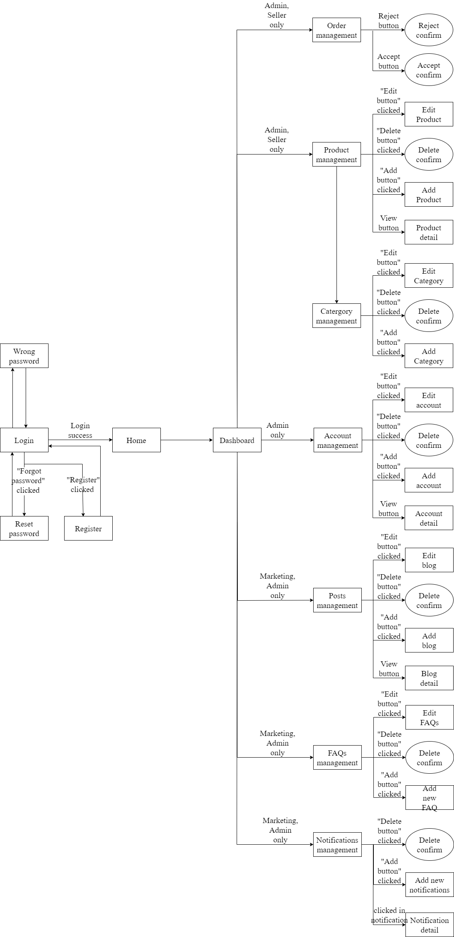

Staff screen flow

#### 

Customers screen flow

1. **Screen Details**

| **No** | **Function/Screen** | **Feature** | **Function/Screen Details** |
| --- | --- | --- | --- |
|  | User Register | Common | This is a screen which allows user register new account by input following information: full name, gender, email, mobile; User need to verify by clicking the link sent via email before login into system |
|  | Reset Password | Common | This is a screen which allows user find account they forgot thought email register. User input email and click in reset password they will receive a mail contain reset password link.  This link will redirect user to password reset form allow user can change password of these own account without old password. |
|  | Wrong password | Common | This is a screen will show message when user input wrong information of login account (password or email)  This screen will auto redirect back in login page |
|  | Login | Common | This is a screen show login form for user want to login in to website |
|  | Profile detail | Common | This is a screen which allows user to view their own profile information, including all personal information & avatar image.  User can change profile detail by click in edit button to redirect in edit profile screen.  User can view order history by click in order history button |
|  | Order history | Common | This screen show information of all game their buy in history(OrderID , Productname, price, date,status) |
|  | Edit profile | Common | This is a screen which allows user to edit their own profile information, including all personal information & avatar image.  Note user not allowed to change email |
|  | Change Password | Common | This is a screen allows the user to change their password by input current password to verifies |
|  | Home | Common | Show sliders, hot posts, featured subjects + the sider with the latest posts, static contacts/links  Shown slider information includes its image and title; the user is redirected to the slider's backlink on their clicking  Show post information includes its thumbnail, title, post date; the user is redirected to the post's details on his/her clicking  Show subject information includes its thumbnail, title, tag line; the user is redirected to the subject's details on their clicking |
|  | Notification list | common | Customers can see all title notification of their account, list by pagination with information (id, title, status, time).  The customers can filter the notifications by status  Allow the customers to search notifications by name |
|  | Notification detail | common | Show detail notification information(id, Content, status, time) |
|  | Product | Common | Show list product the right side with the post search box, product categories, eight featured products (thumbnail, title, price); Product information includes its thumbnail, title, category, brief-info; the user is redirected to the Product Details page on his/her clicking on a product, redirected to this Product List page if the user clicks on a product category |
|  | Product Detail | Common | Show details (including name, thumbnail, brief info, lowest price plan option (original price, discount price), product description and Buy button) of product user choose in product list  User can increase or decrease the number of products added to the cart  After choose right amount of product user can click in add to cart button to put product in cart to buy it later |
|  | Cart | Common | All product user put to cart prepare to payment  Customer can change detail cart (product) beford checkout  After check all information correct user can checkout |
|  | Checkout | Common | This screen will show all information of your order (OrderID , ProductName, User information, price, date)  After check all information is correct click in payment button to view payment screen |
|  | Payment information | Common | This screen will guide users how to payment their order will full information of bank account , content transfer, price user need to pay |
|  | About Us | Common | This is a screen allow user contact to admin by input following information: full name, user title (Mr, Mrs, Ms,..), email, mobile, address; |
|  | Posts List | Common | Show blog list with the post search box, posts categories, latest posts, static contacts/links; Show post information includes its thumbnail, title, category, brief-info; the user is redirected to the post's details on their clicking |
|  | Port Details | Common | Show details (including title, author, updated date, category, and post details) of blog user choose in blogs list |
|  | Dashboard | Admin, seller, marketing | This screen for staff only  It give all staff member abilities to change information in system depend on their roll |
|  | Order Management | Admin | Admin can see all order list by pagination with information (id, Total Price, date, note).  admin can filter the orders by status  Allow admin to search orders by name  From each order, admin can choose to view detail  Show detail order with information(id, Total Price ,date , note) can view, edit/update the information of the order |
|  | Product Management | Admin | Admin can see all product list with information(id, name, thumbnail, original price, sale price, category, status, description).  Admin can filter the products by status  Allow the admin to search products by name  Admin can choose view product their choose  Admin can add new product in to product list  Show detail product information (id, name, thumbnail, original price, sale price, category, status, description)  The admin can edit/update the information of the product |
|  | Category Management | Admin | Admin can see all category list with information(id, category name).  Allow the admin to search category by name  Admin can choose view category their want  Admin can add new category in to category list  The admin can edit/update the information of the product |
|  | Account Management | Admin | Show the paginated list of accounts (include user id, full name, gender, email, mobile, role, status):  The admin can filter the account by role, status  Allow the admin to search accounts by full name, email…  From each account, admin can choose to view or edit it  The page also have the button/link that allows the admin to add new account |
|  | Posts Management | Marketing, Admin | Admin and marketing roll can see all blog list by pagination with information(id, author, title, content, image).  Admin and marketing can filter the blogs by date and name  Admin and marketing can search blogs by name  Admin and marketing can choose blog to view detail and edit  Admin and marketing can write new blog  Show detailed blog information (id, author, title, content, image)  Admin and marketing can edit/update the information of the blog |
|  | Notification Management | Admin | Admin can see all notification list by pagination with information(id, UserID, OrderID, Content, status, time).  The admin can filter the notifications by status  Allow the admin to search notifications by name  Show detailed notification information(id, UserID, OrderID, Content, status, time), allow the admin to add new or view notification information |
|  | FAQs management | Admin, marketing | Admin and marketing roll can see all FAQs list by pagination with information(id, author, title, content, date).  Admin and marketing can filter the FAQs by date and name  Admin and marketing can search FAQs by name  Admin and marketing can choose FAQs to view detail and edit  Admin and marketing can write new FAQs  Show detailed FAQs information (id, author, title, content, date)  Admin and marketing can edit/update the information of the FAQs |

#### c. User Authorization

| **Screen** | **Admin** | **Marketing** | **Seller** | **Customer** |
| --- | --- | --- | --- | --- |
| Login | X | X | X | X |
| Home Page | X | X | X | X |
| Change Password | X | X | X | X |
| About Us | X | X | X | X |
| Check Out |  |  |  | X |
| Dashboard | X | X | X |  |
| Review | X | X | X | X |
| View Customer | X | X | X | X |
| Invalid Role | X | X | X | X |
| User Profile | X | X | X | X |
| Account Management | X |  |  |  |
| Reset Password | X | X | X | X |
| Cart |  |  |  | X |
| Error | X | X | X | X |
| Check out |  |  |  | X |
| Post management | X | X |  |  |
| List Post | X | X | X | X |
| Detail Post | X | X | X | X |
| Product list | X | X | X | X |
| Product Management | X |  | X |  |
| Order management | X | X | X |  |
| View Order Detail | X | X | X | X |
| View Order History | X | X | X | X |
| FQAs management |  | X |  |  |
| FQAs list | X | X | X | X |
| Category management | X |  |  |  |
| Notification management | X |  |  |  |

#### Non-Screen Functions

| **#** | **Feature** | **System Function** | **Description** |
| --- | --- | --- | --- |
| 1 | Database access | Read and write to database | Read and write to database |
| 2 | User authorise | Check account roll in database | Implementation of authorization mechanism in the system, including the specify the role of logged-in user, his/her authorized page links (building the displayed menu items (in the front end) and preventing unauthorized access via enter the links directly) |

# II. Functional Requirements

## Login

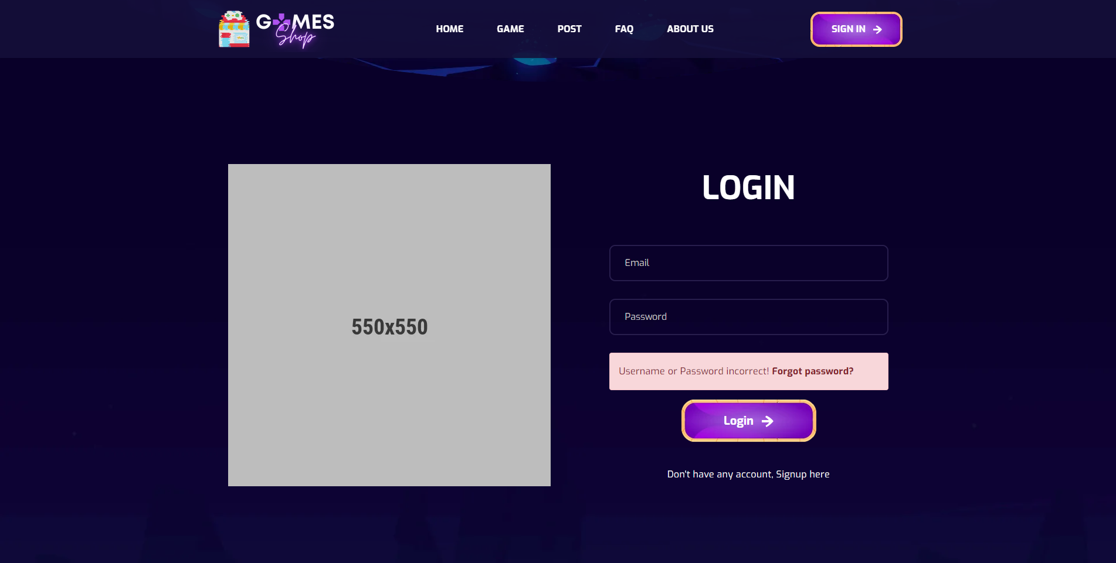

- Data initializing in screen components: N/A  
- Business logics inside: When user visited home page and select login/register link. User will be redirected to this website and can perform login into the website

- Data validations: Email had correct syntax  
- Functionalities: Login

## Signup

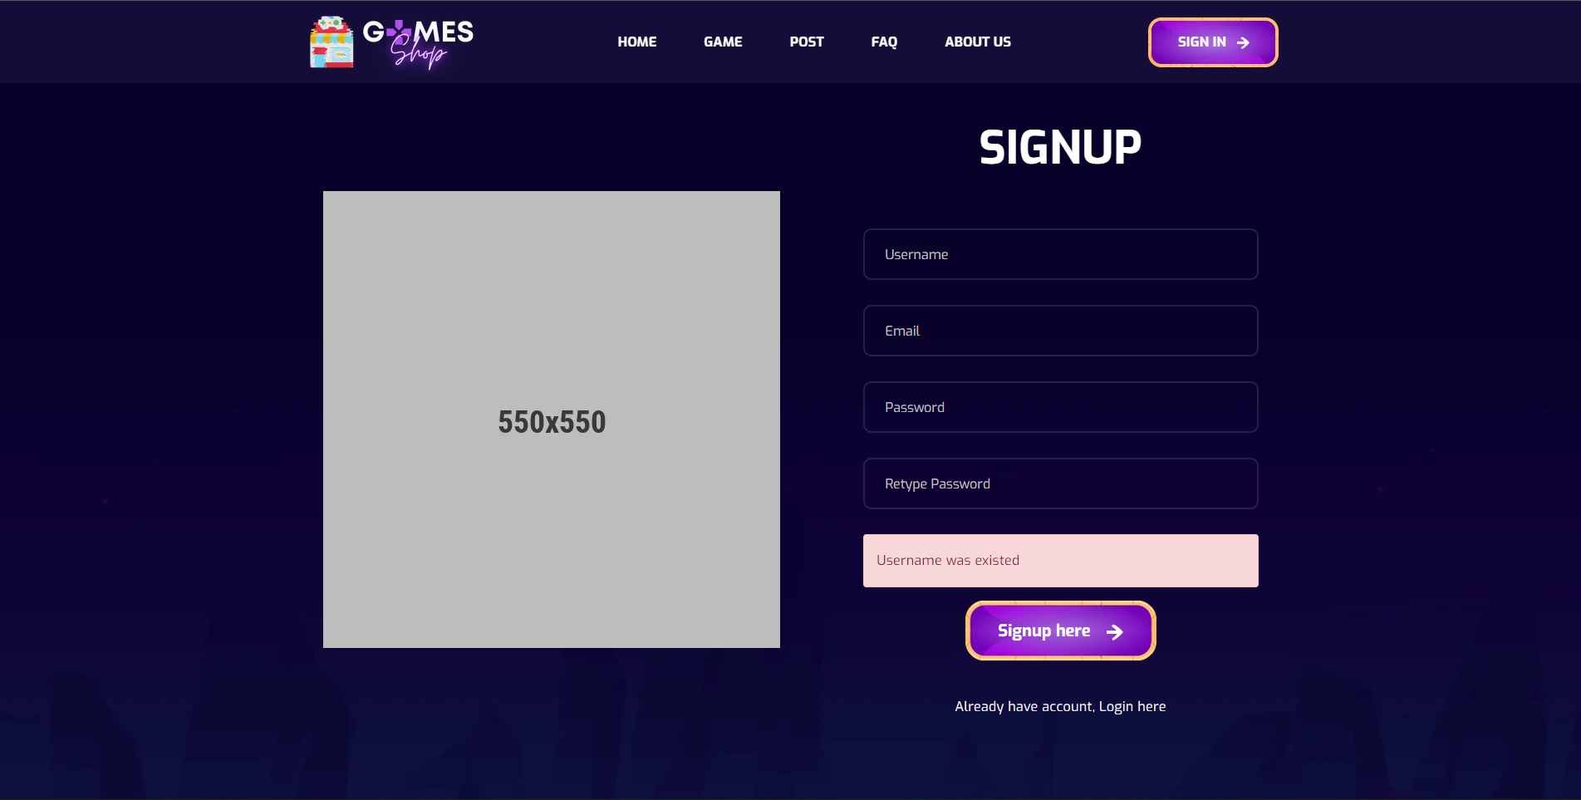

- Data initializing in screen components: N/A  
- Business logics inside: When user visited home page and select login/register link. User will be redirected to this website and can perform register into the website  
- Data validations: Email had correct syntax, Password match retype password,   
  
- Functionalities: Register

## Forget password

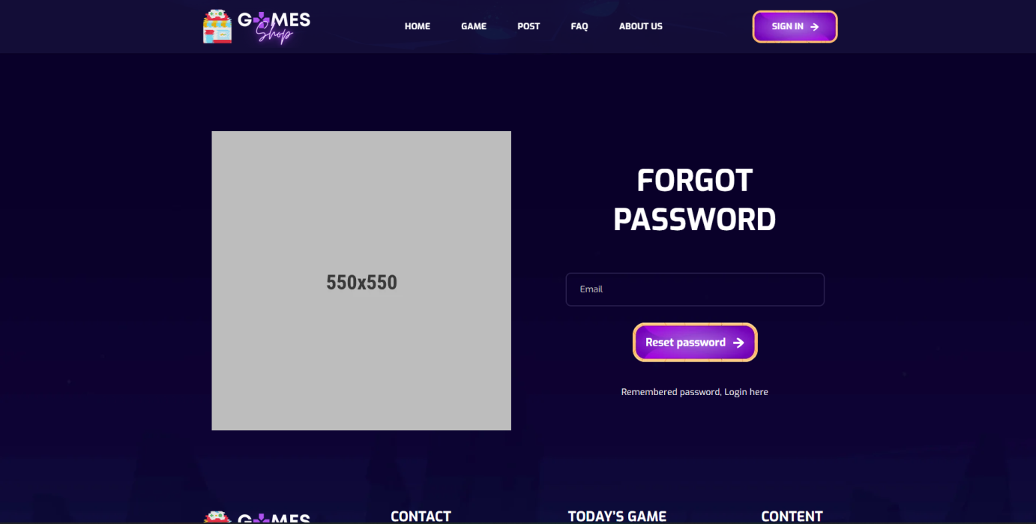

- Data initializing in screen components: N/A  
- Business logics inside: When user visited home page and forget password, select “forgot password” link. User will be redirected to this website and get back their password  
- Data validations: Email had correct syntax  
- Functionalities: Reset password

## Homepage

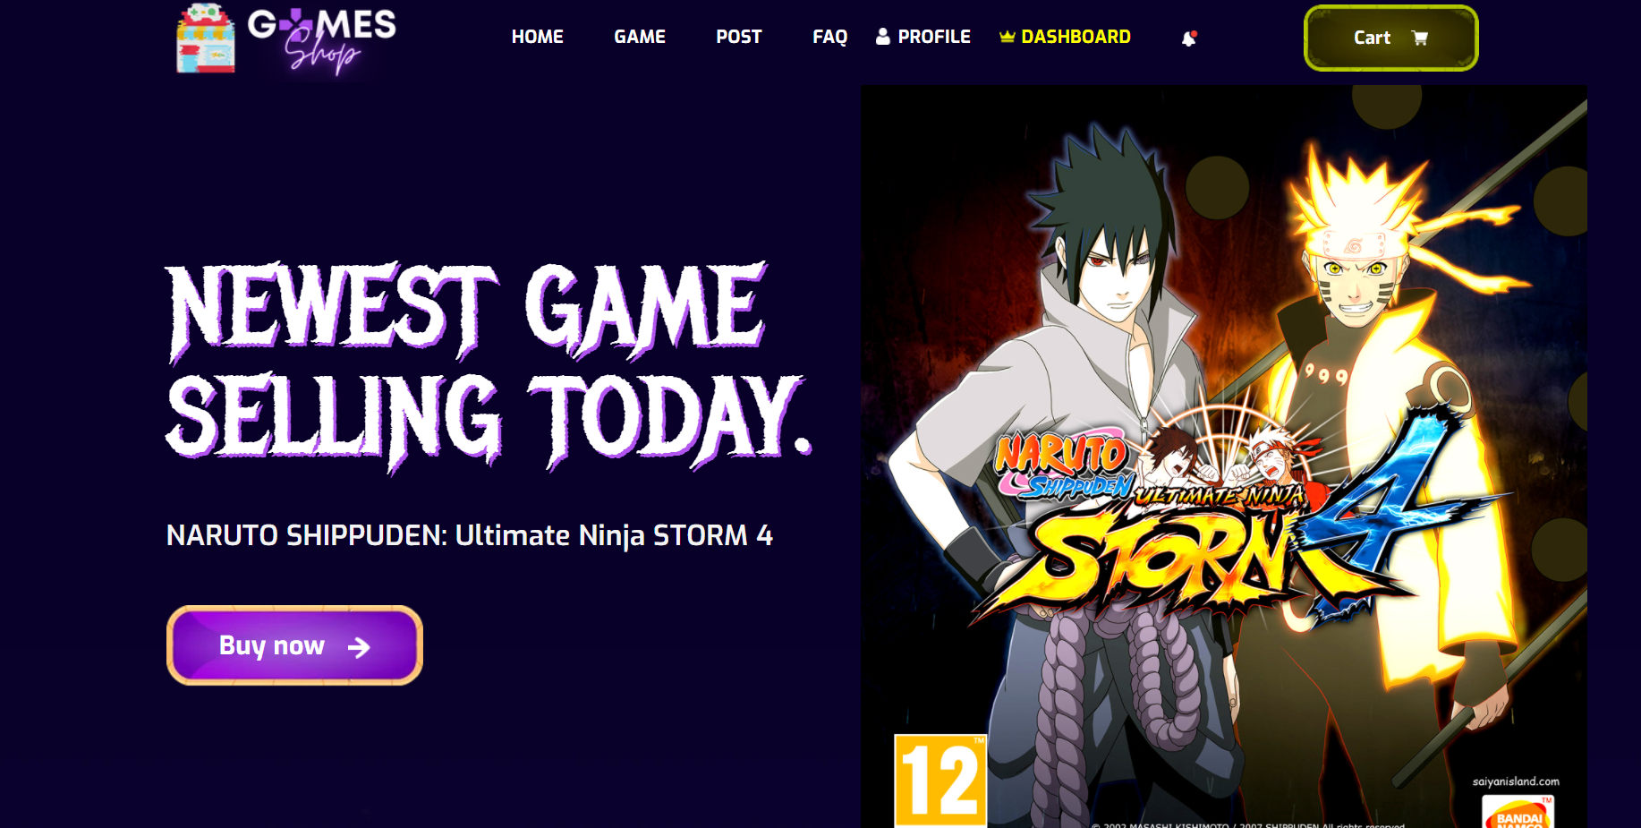

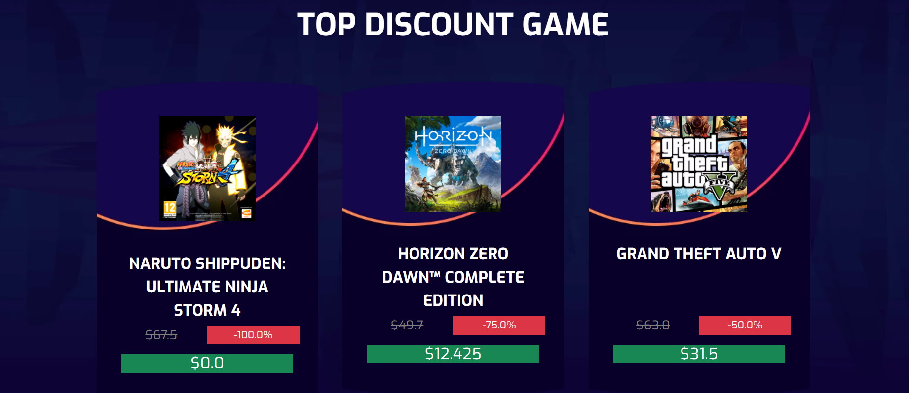

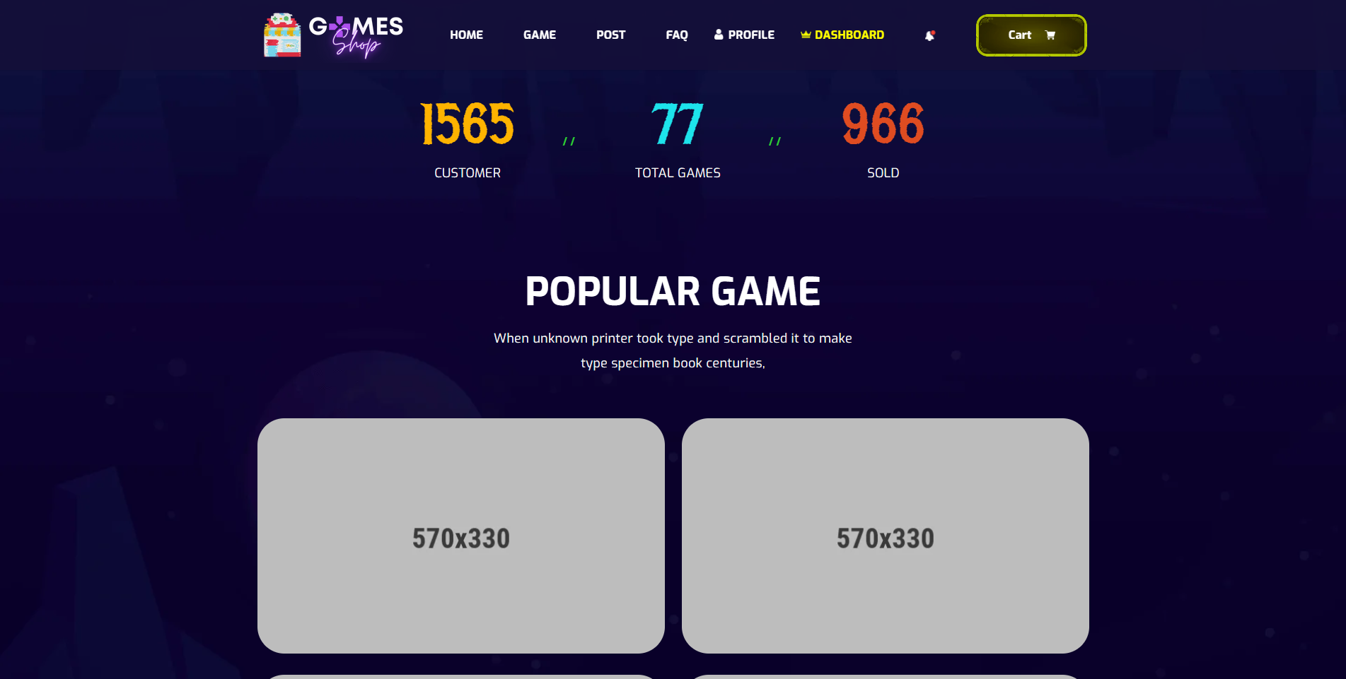

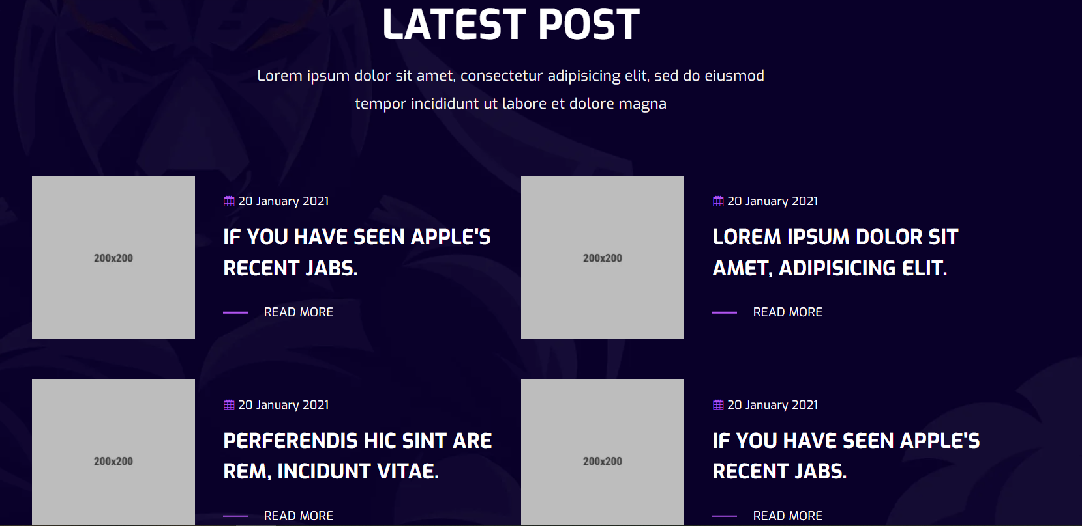

- Data initializing in screen components:

+Lastest product

+ Product list

+ Post list

+ Total product

+ Total user

+ Total number of products sold  
- Business logics inside:

+User Authorization  
- Data validations: N/A  
- Functionalities:

+Latest product

+Top 3 games with the highest promotion

+Top 4 games with the most buyers

+Top 4 latest post

## 5. Product

* 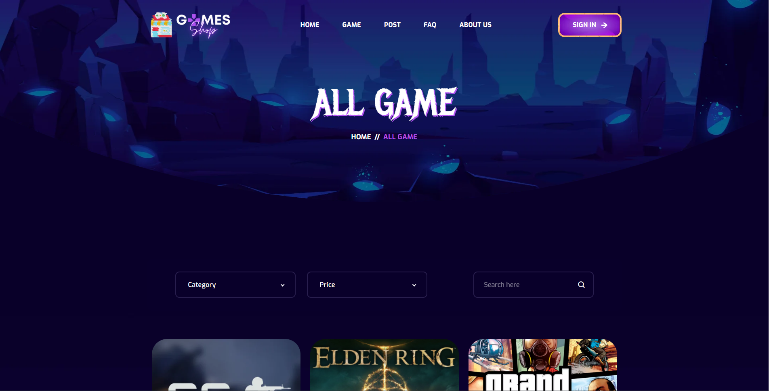

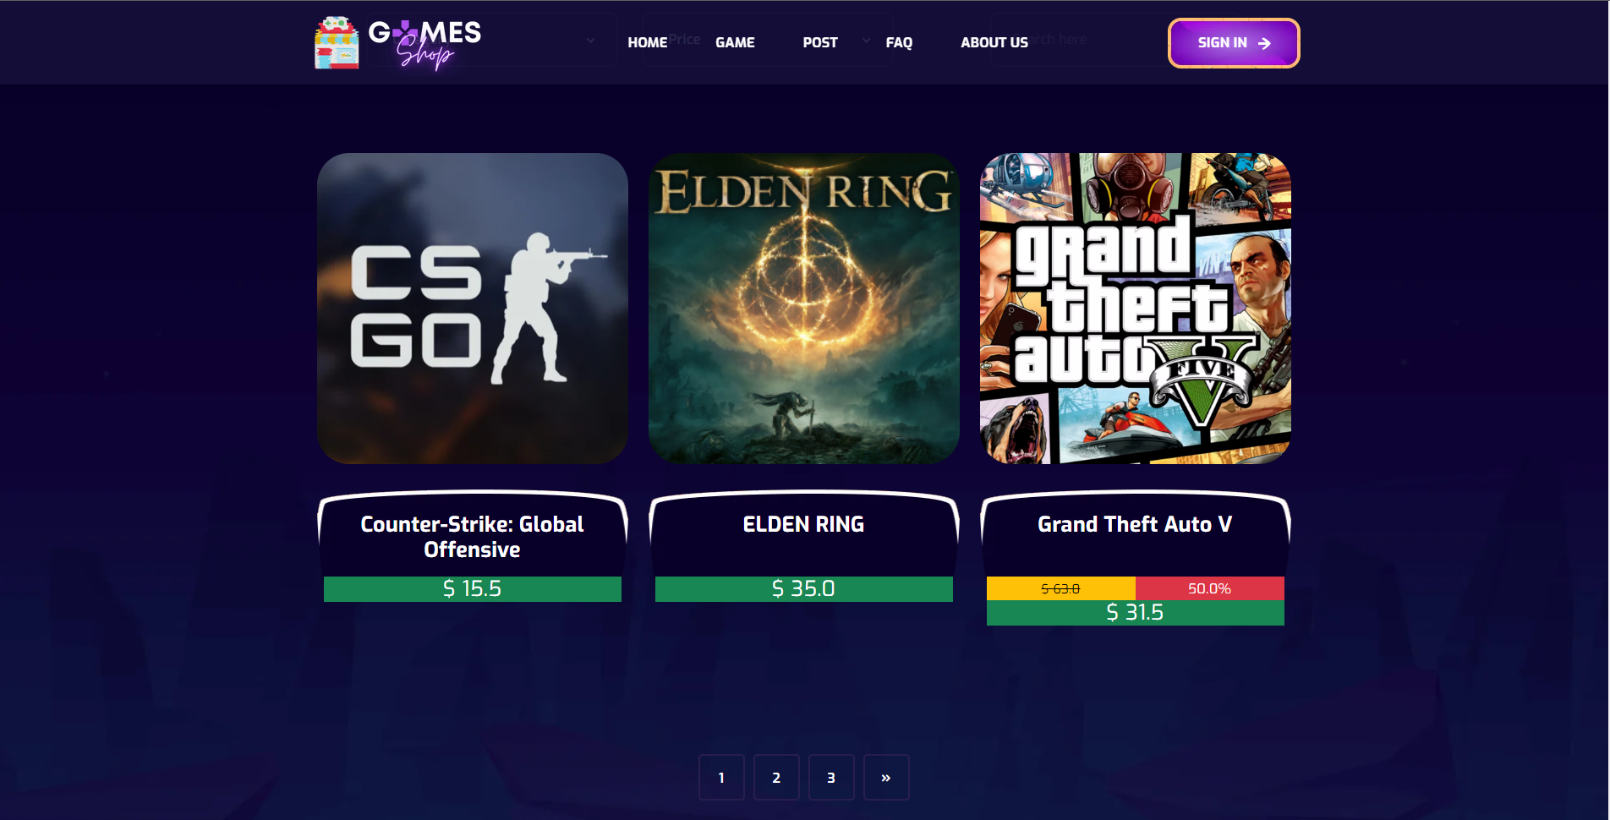

- Data initializing in screen components:

+Product list

+Productimg list

+Category List

- Business logics inside:

Users can view and search products

- Data validations:N/A  
- Functionalities:

+Paging

+Show detail product

+Search by text, category, price

## 6. Product detail

* 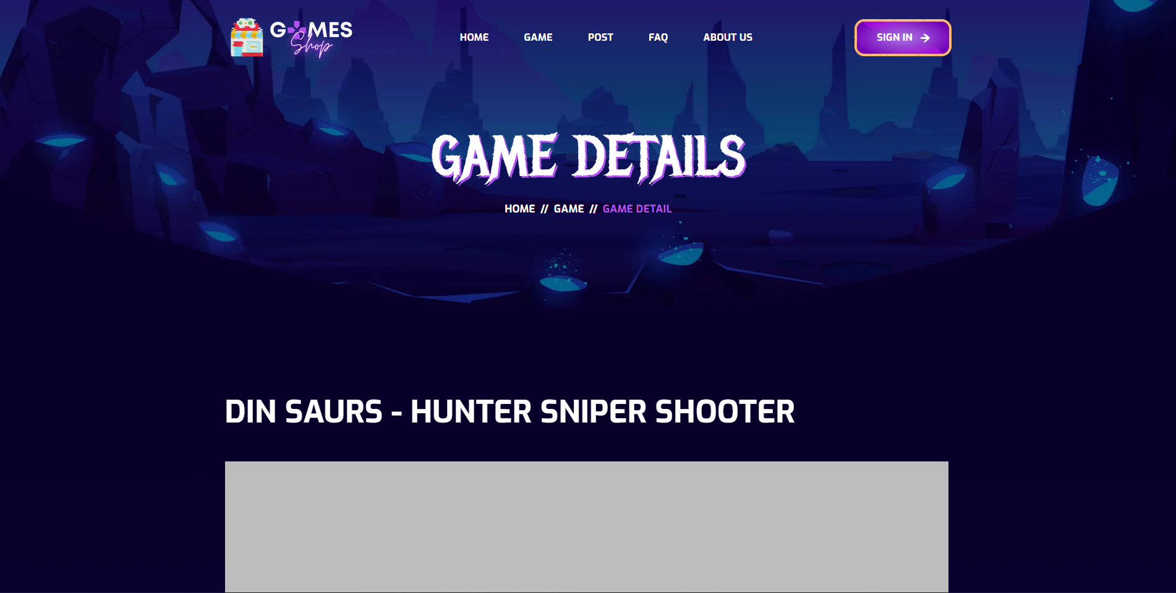
* 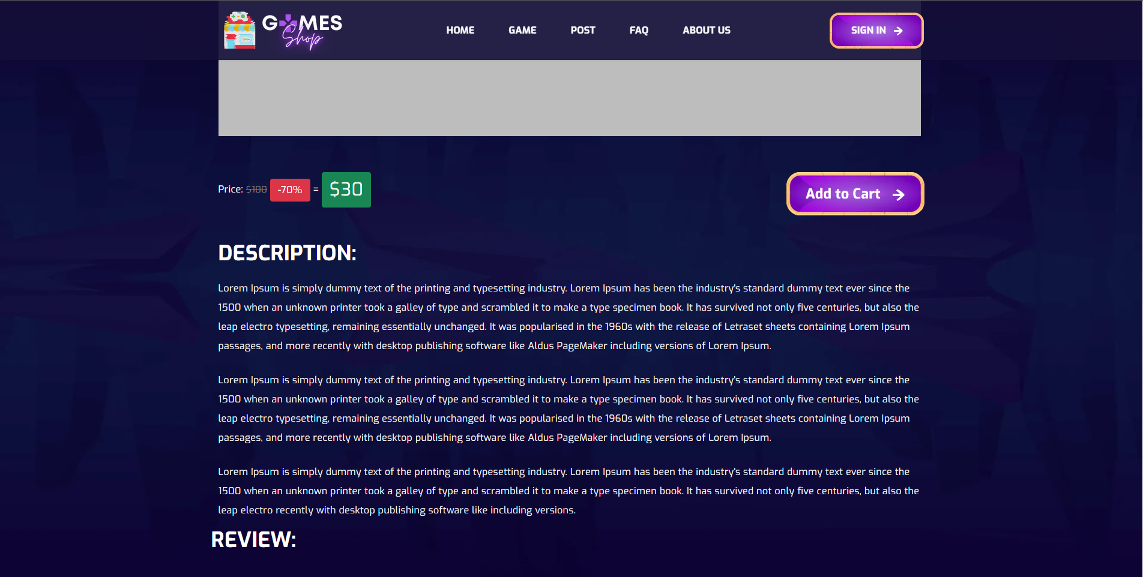

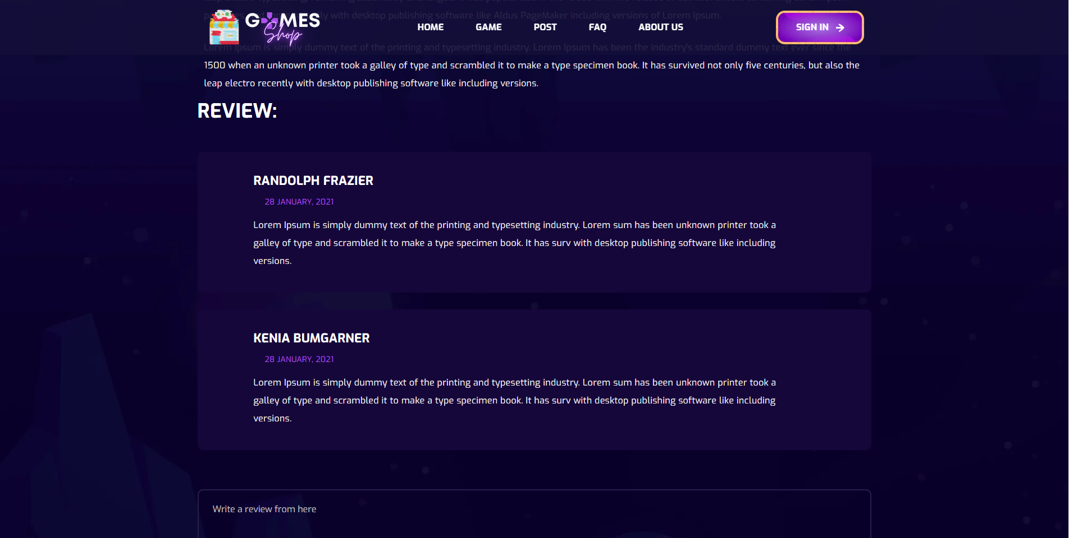

- Data initializing in screen components:

+Product detail  
- Business logics inside: show details of the product   
- Data validations:N/A  
- Functionalities:

+Show detail product

## 7. User Profile

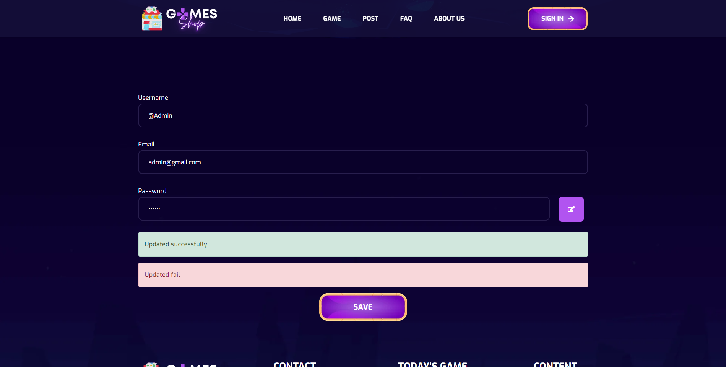

- Data initializing in screen components: User profile detail(username, email, password)  
- Business logics inside:When user signed in, we send redirect to homepage and user can change their profile in setting profile. Select “Profile” link, select “Profile Setting” User will be redirected to edit profile screen. After change Username or Email, select “Save” to request submit their change.

- Data validations: Username, email have correct syntax  
- Functionalities: Edit Profile

## 8. Change password

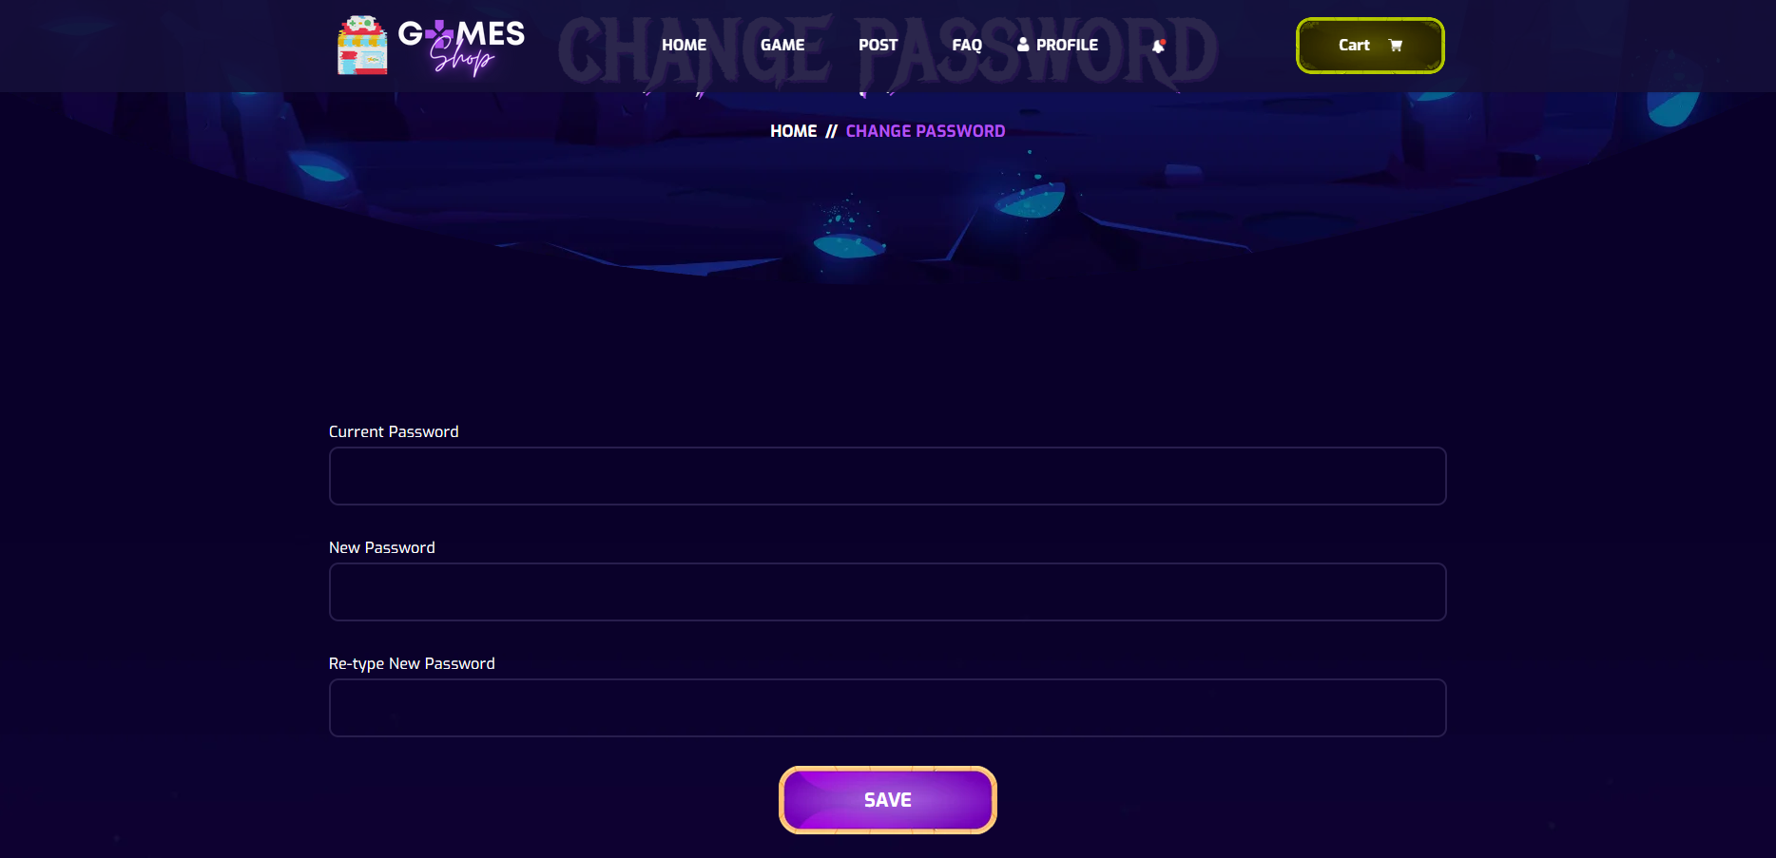

- Data initializing in screen components: N/A  
- Business logics inside: When user signed in, we send redirect to homepage and user can change password in setting profile. Select “Profile” link, select “Change Password” User will be redirected to Change Password screen.  
- Data validations: Current password matches password in database, new password and retype password have correct syntax and match each other.  
- Functionalities: Change password

## 9. Post

* 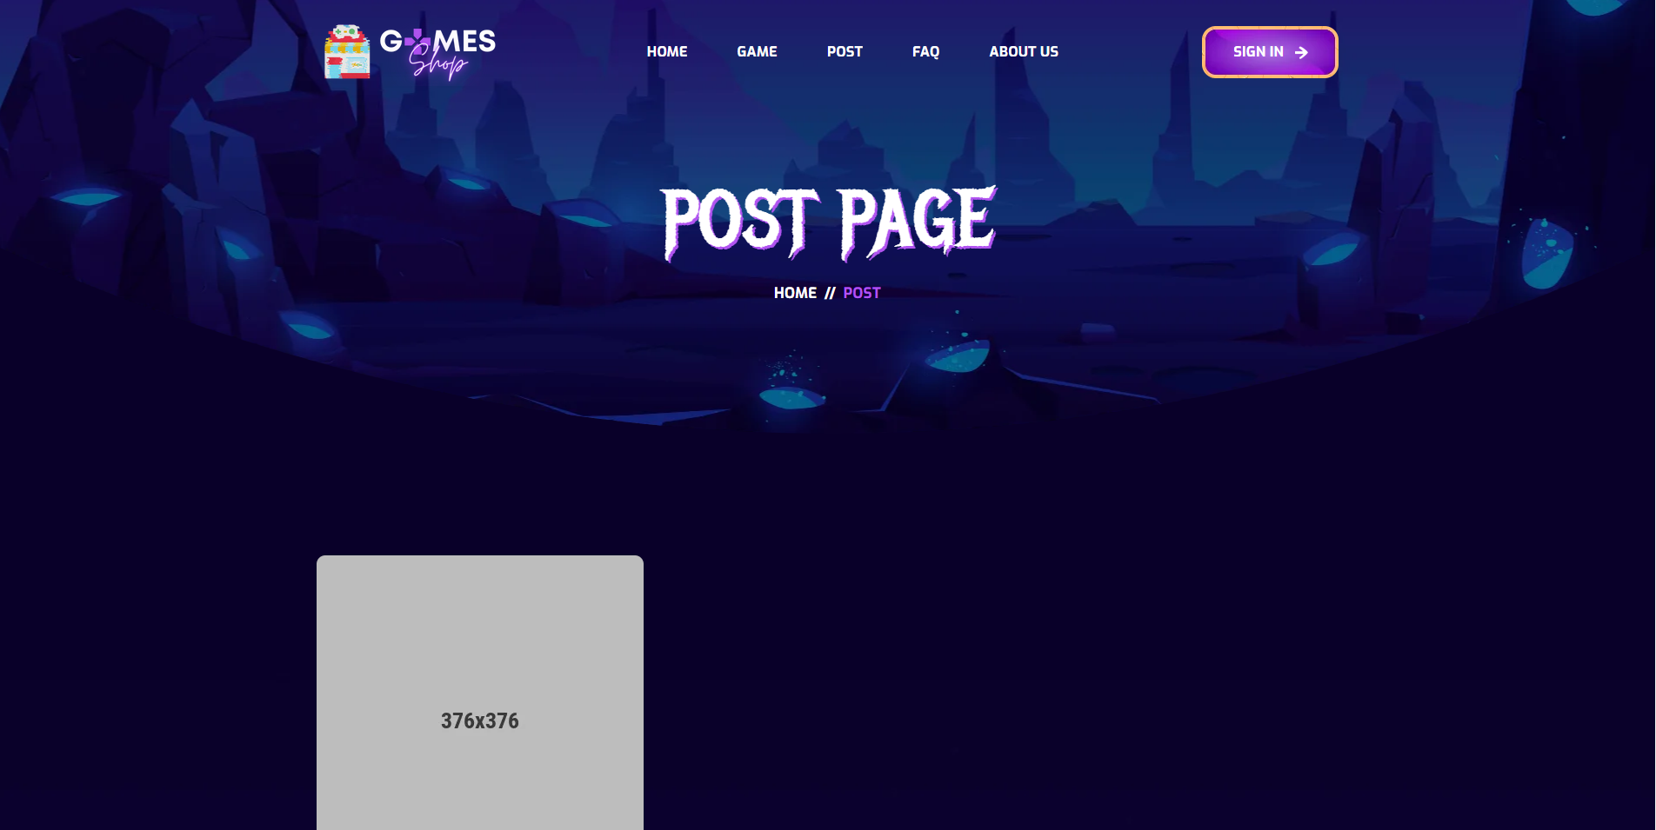

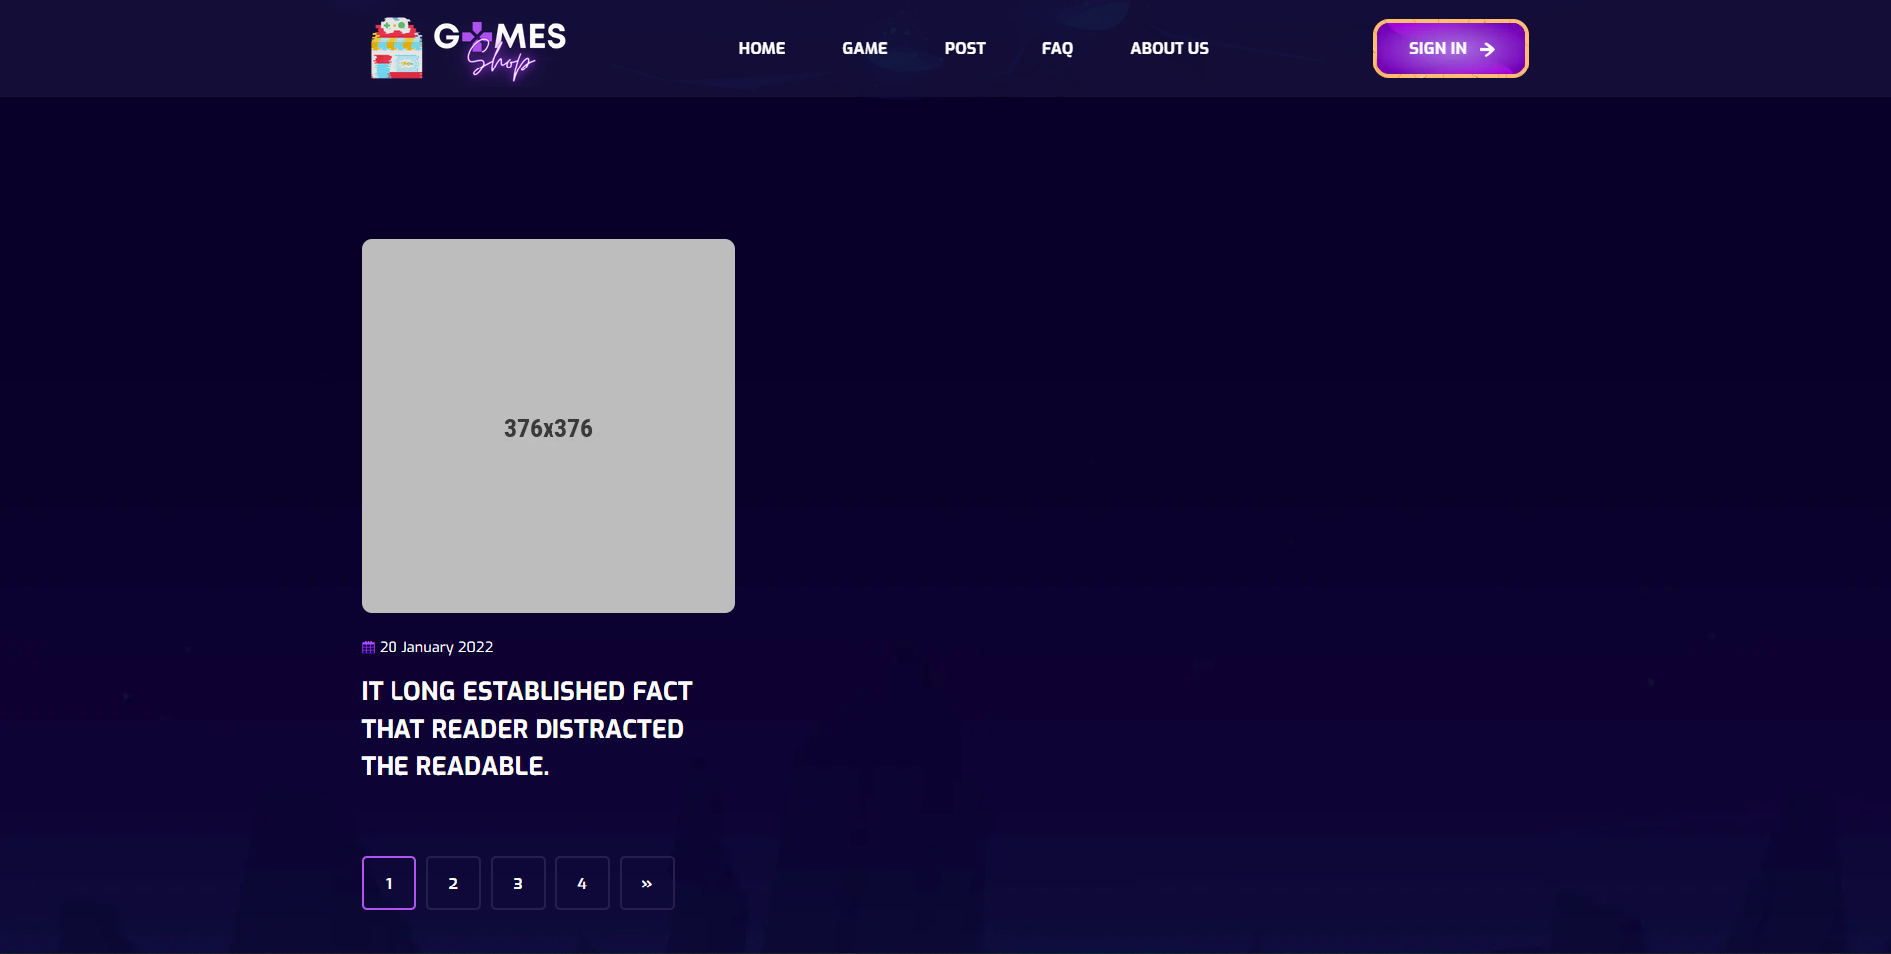

- Data initializing in screen components:  
- Business logics inside:  
- Data validations:  
- Functionalities:

## 10. Blog Details



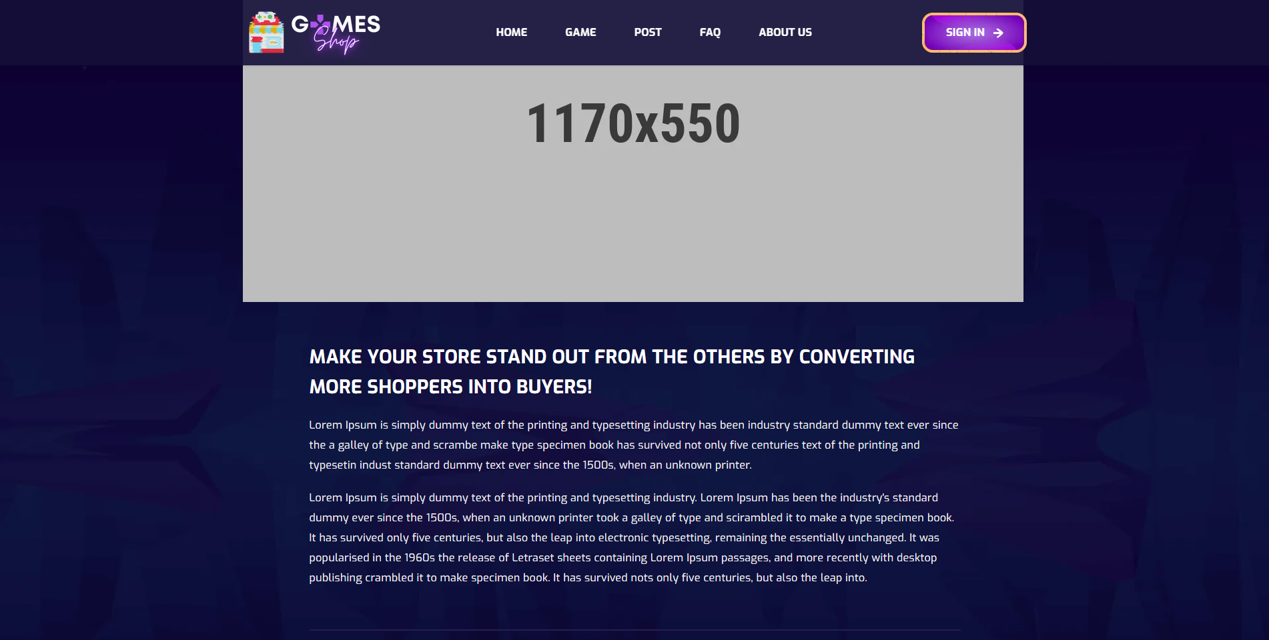

- Data initializing in screen components:  
- Business logics inside:  
- Data validations:  
- Functionalities:

## 11. FAQs

* 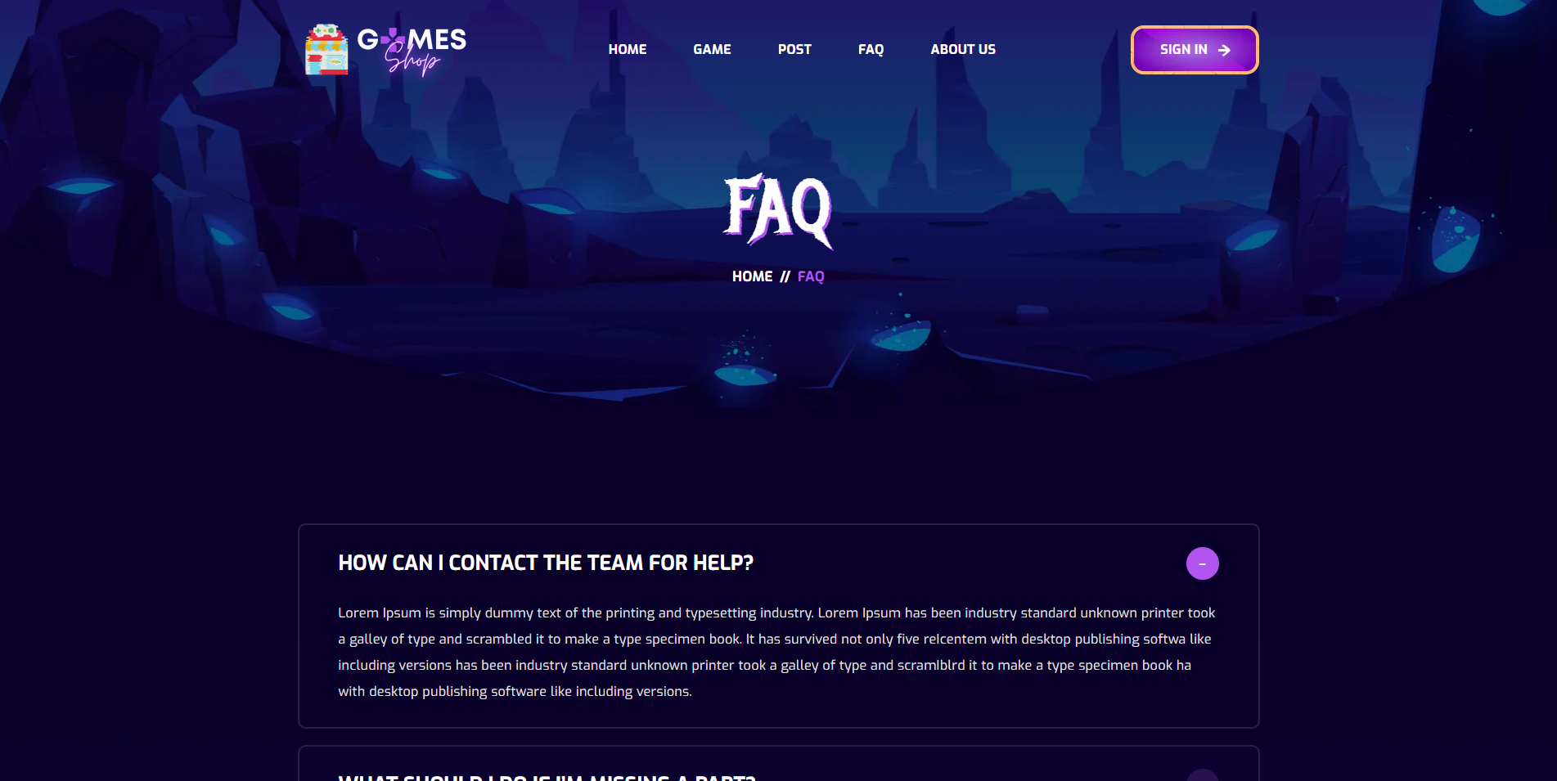

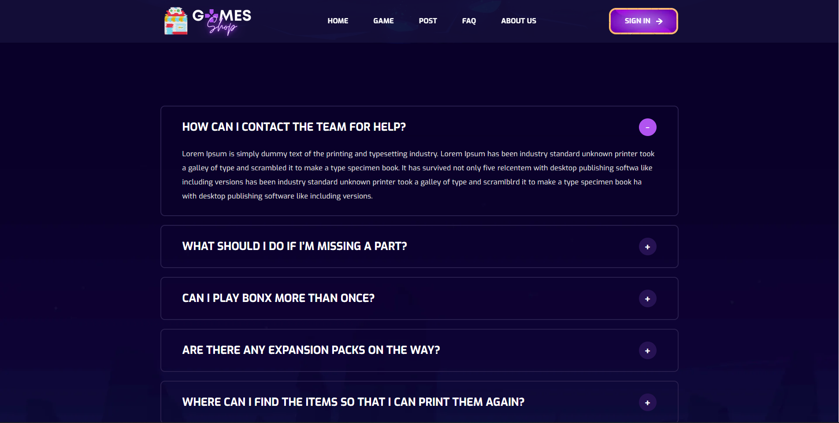

- Data initializing in screen components:  
- Business logics inside:  
- Data validations:  
- Functionalities:

## 12. Notification

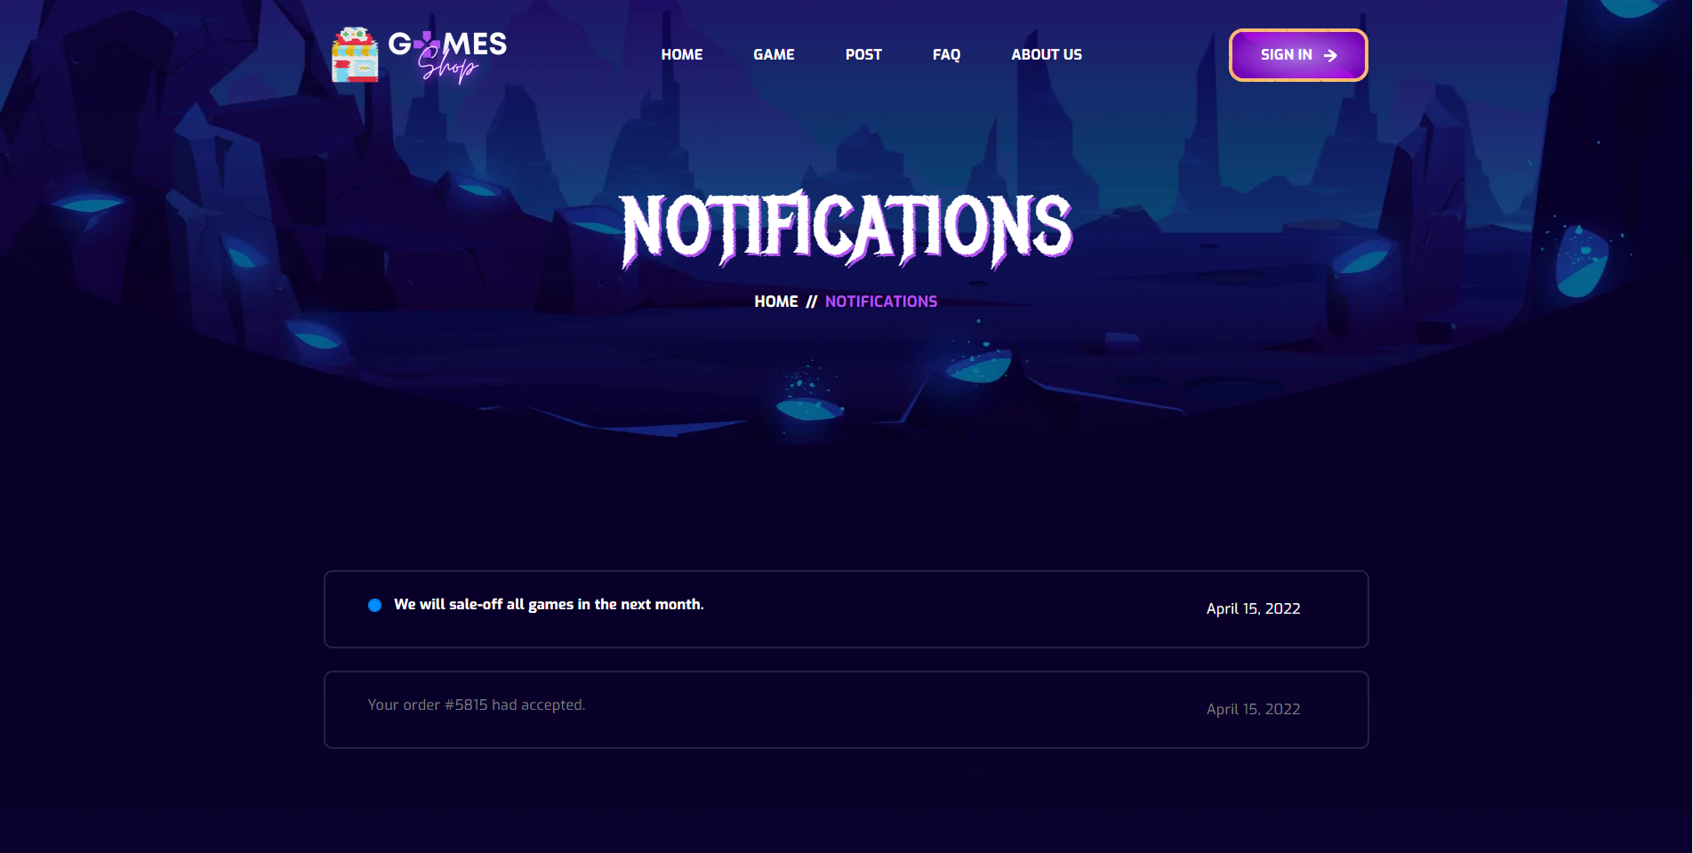

- Data initializing in screen components:  
- Business logics inside:  
- Data validations:  
- Functionalities:

**13. Cart**

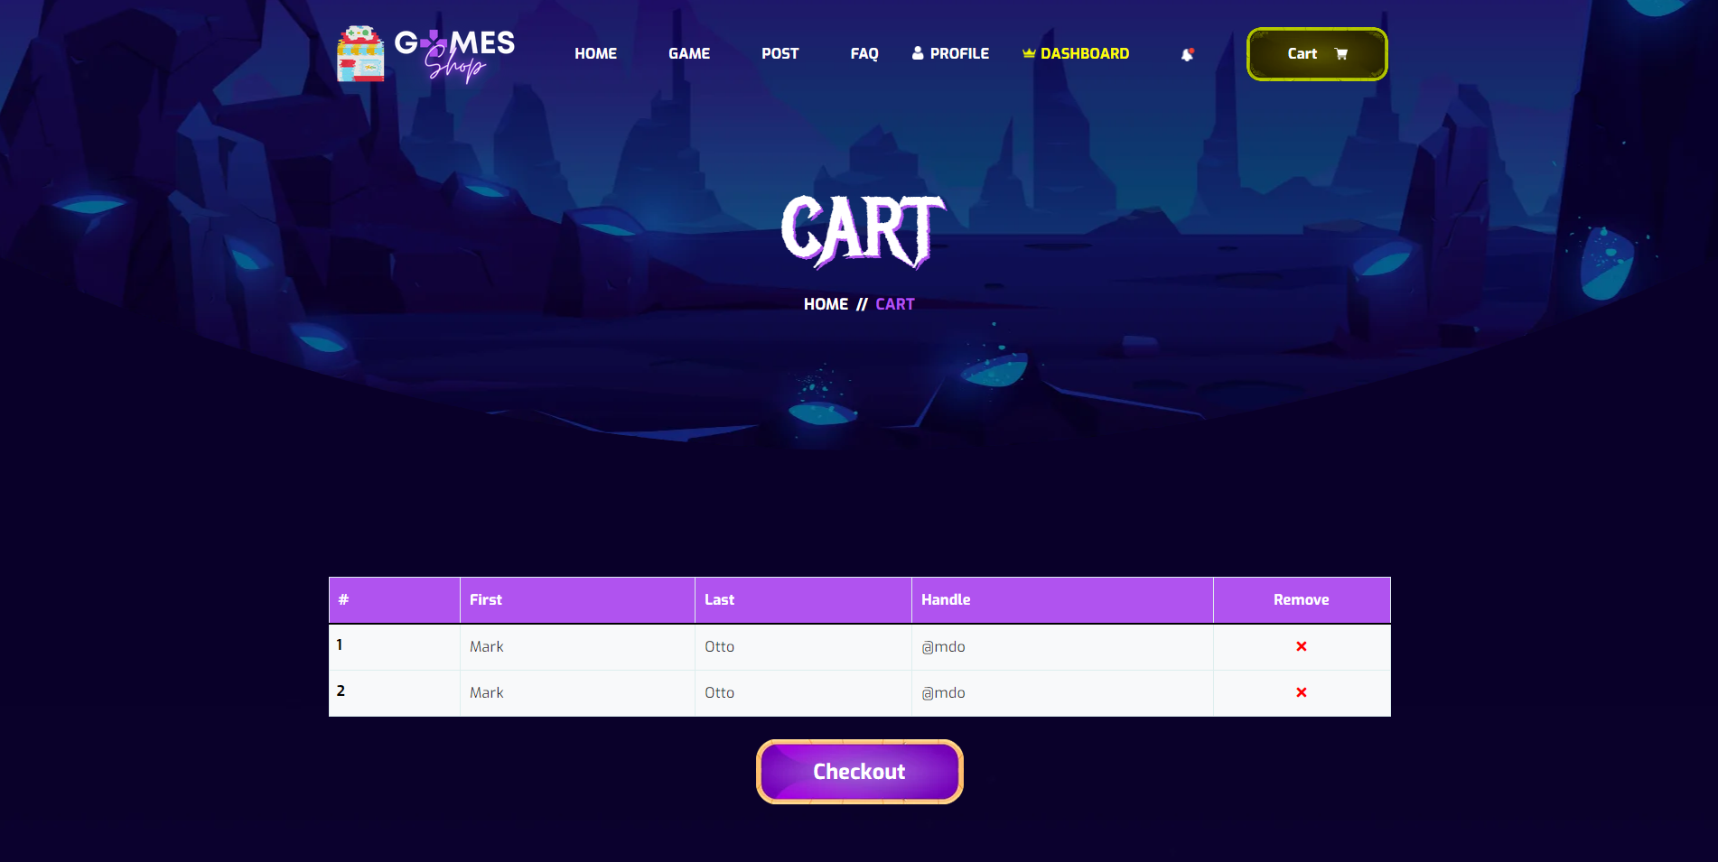

- Data initializing in screen components:  
- Business logics inside:  
- Data validations:  
- Functionalities:

**14. Checkout**

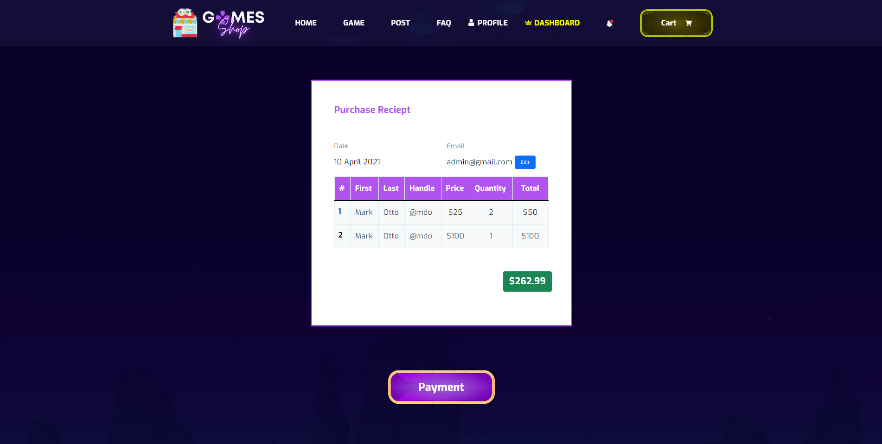

- Data initializing in screen components:  
- Business logics inside:  
- Data validations:  
- Functionalities:

**15. Payment**

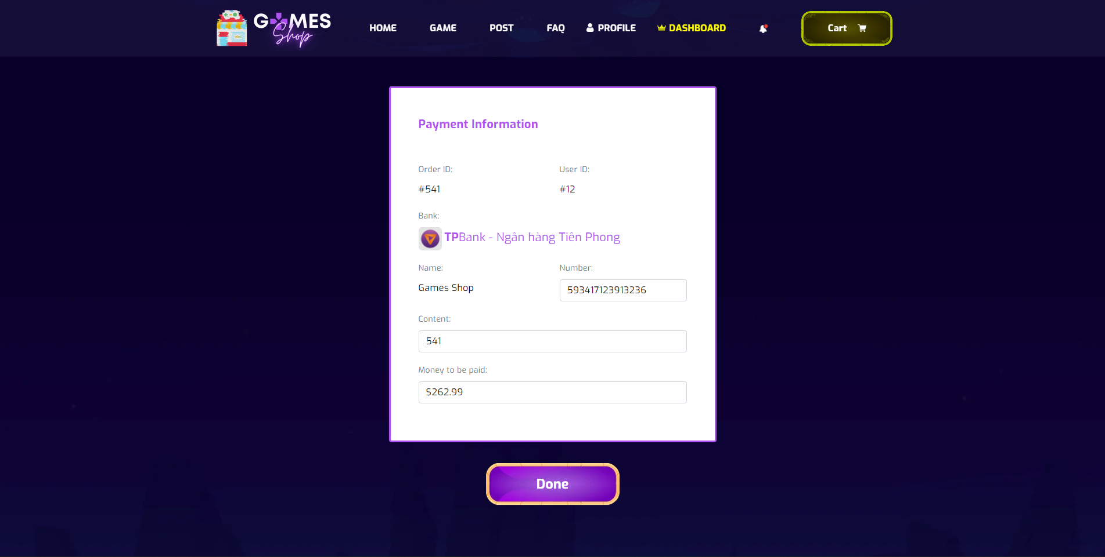

- Data initializing in screen components:  
- Business logics inside:  
- Data validations:  
- Functionalities:

**16. Order History**

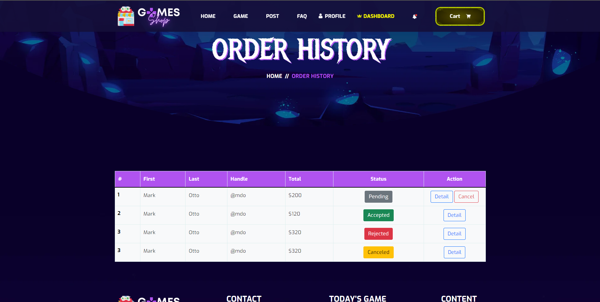

- Data initializing in screen components:  
- Business logics inside:  
- Data validations:  
- Functionalities:

**17. Order History Detail**

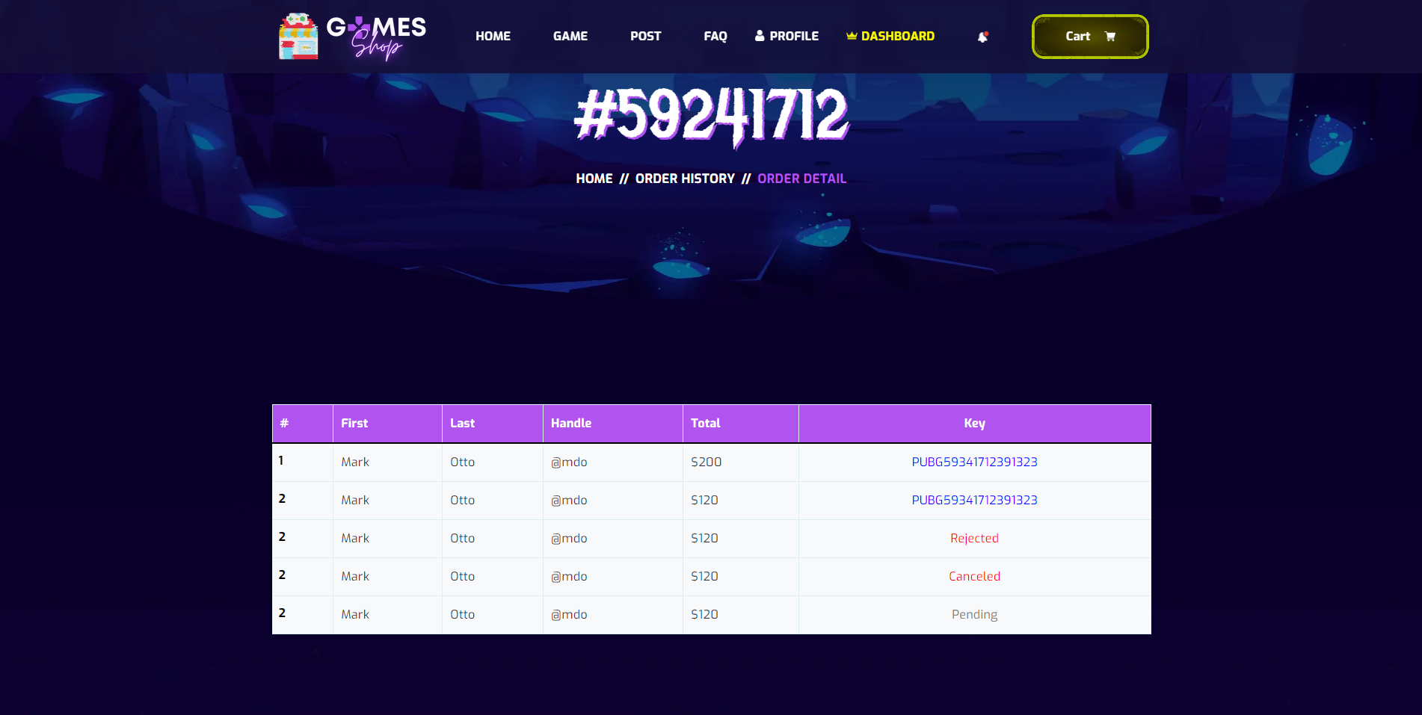

- Data initializing in screen components:  
- Business logics inside:  
- Data validations:  
- Functionalities:

18. **Dashboard**

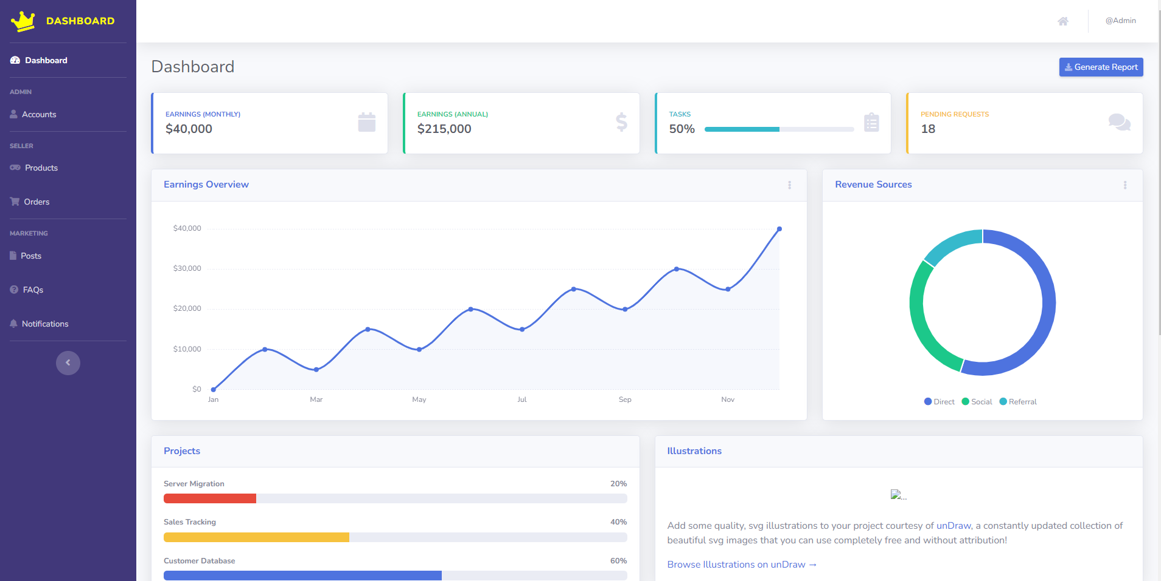- Data initializing in screen components:  
- Business logics inside:  
- Data validations:  
- Functionalities:



19. **Account Dashboard**

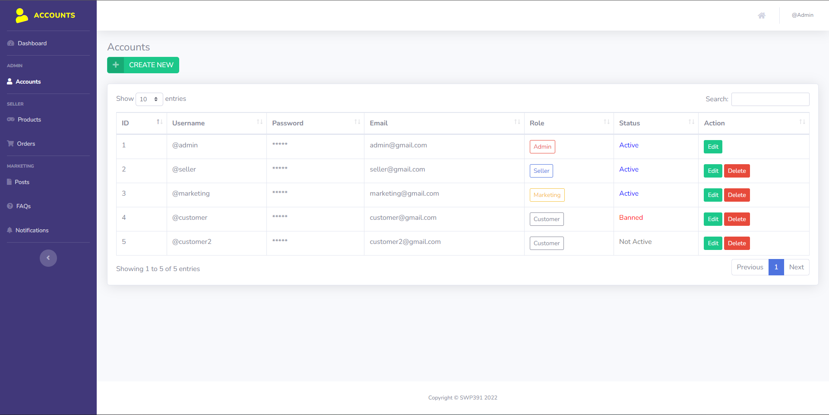- Data initializing in screen components:  
- Business logics inside:  
- Data validations:  
- Functionalities:

20. **Product Dashboard**

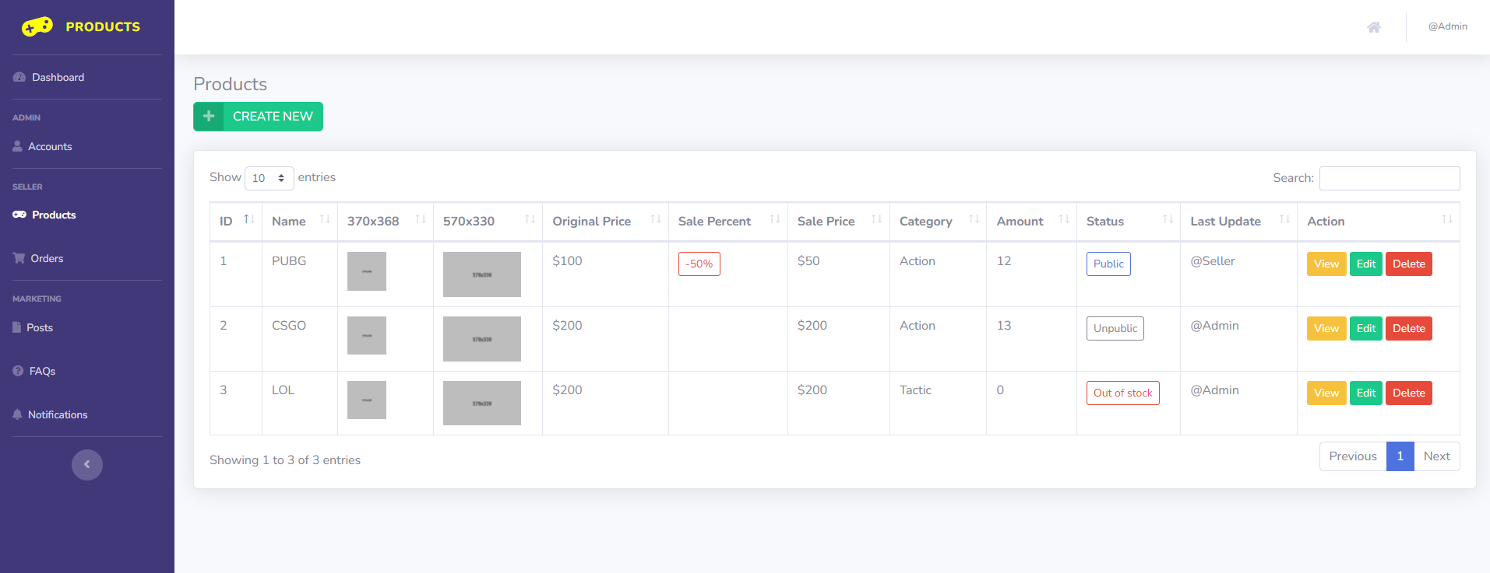- Data initializing in screen components:  
- Business logics inside:  
- Data validations:  
- Functionalities:

21. **Categories Dashboard**

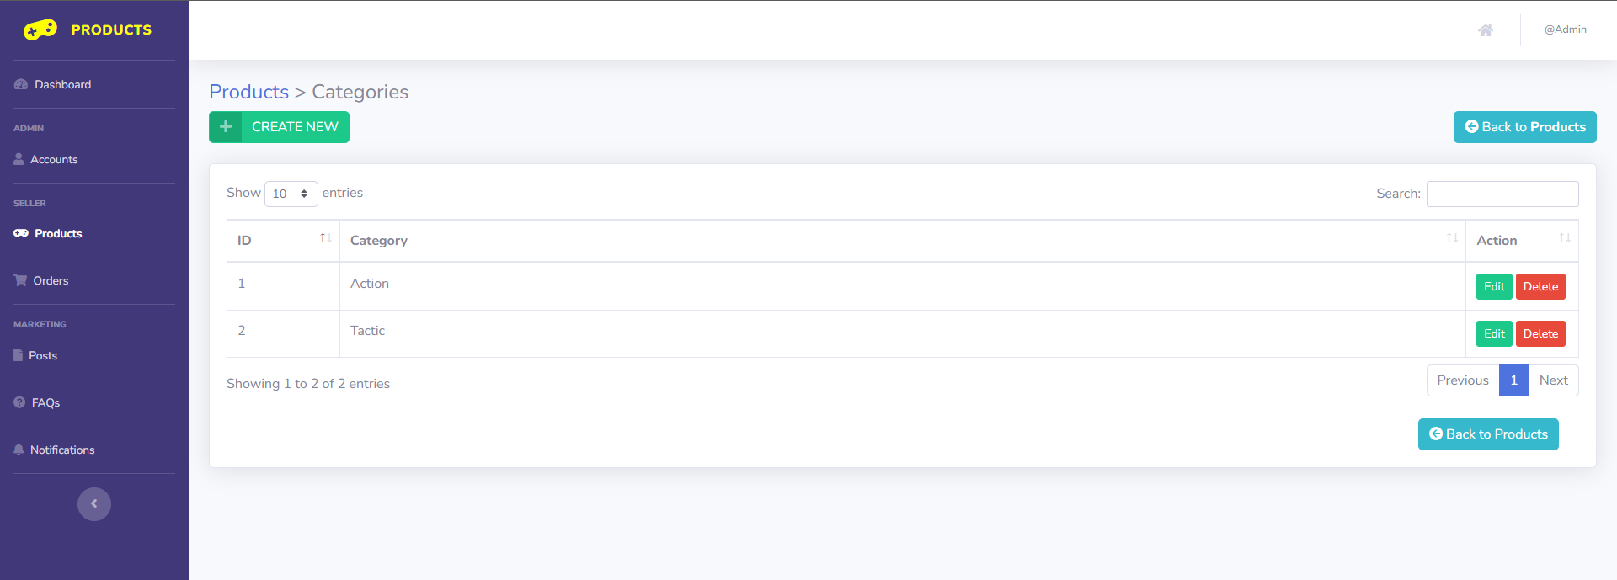- Data initializing in screen components:  
- Business logics inside:  
- Data validations:  
- Functionalities:

22. **Order Dashboard**

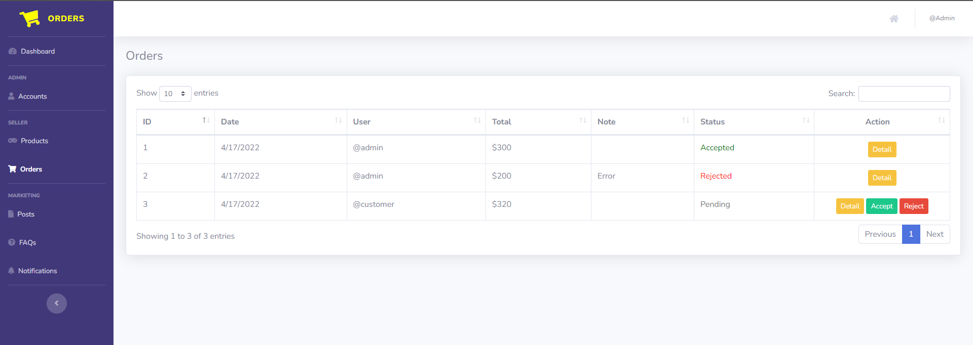- Data initializing in screen components:  
- Business logics inside:  
- Data validations:  
- Functionalities:

23. **Posts Dashboard**

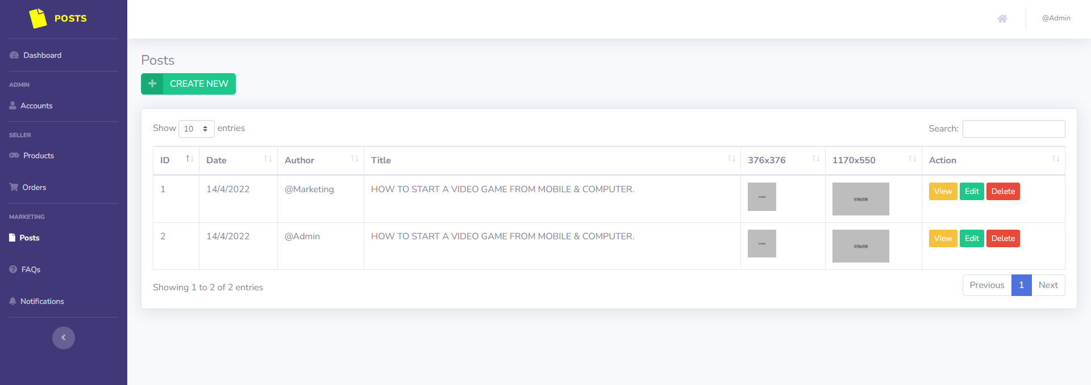- Data initializing in screen components: Post list, Post detail  
- Business logics inside: This is Post page at Dashboard, marketing can control and management posts in website at here.  
- Data validations: Required field is not empty  
- Functionalities: Create new Post, View detail Post, Edit post, Delete post

24. **FAQs Dashboard**

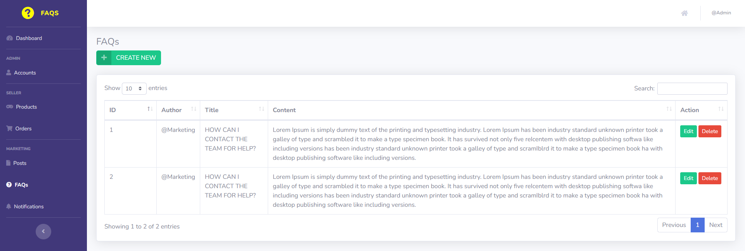- Data initializing in screen components:  
- Business logics inside:  
- Data validations:  
- Functionalities:

25. **Notifications Dashboard**

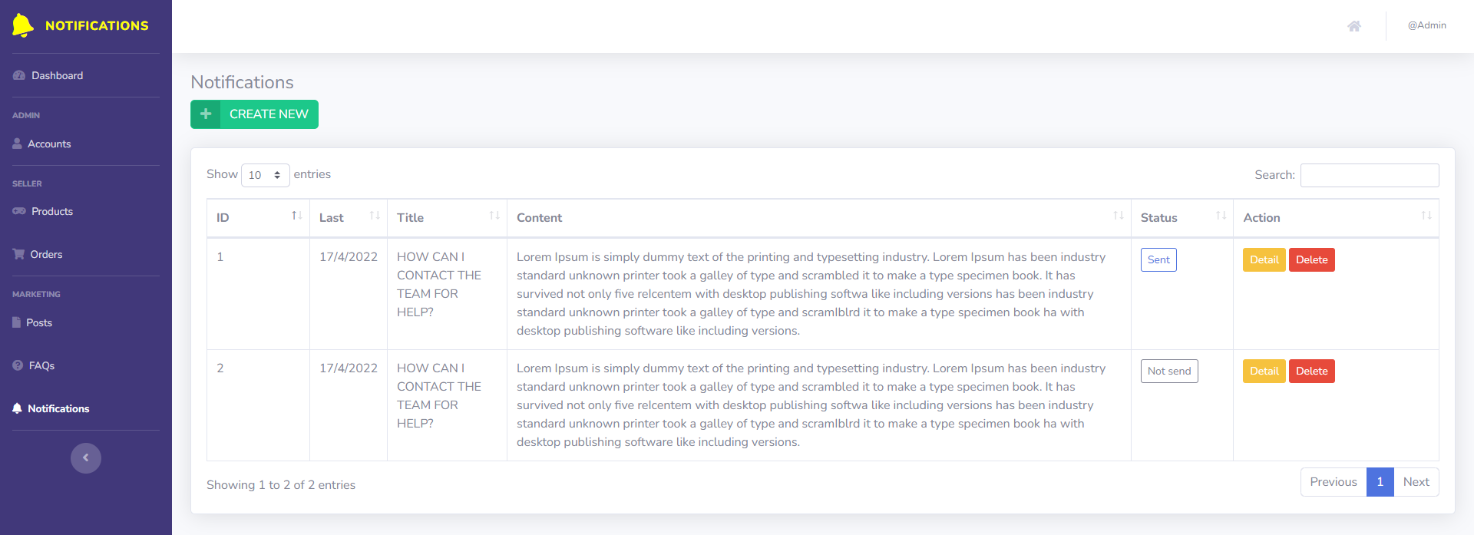- Data initializing in screen components:  
- Business logics inside:  
- Data validations:  
- Functionalities: